TJ ŠTEFANYDES POLIČKA
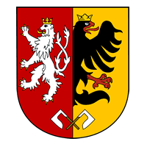
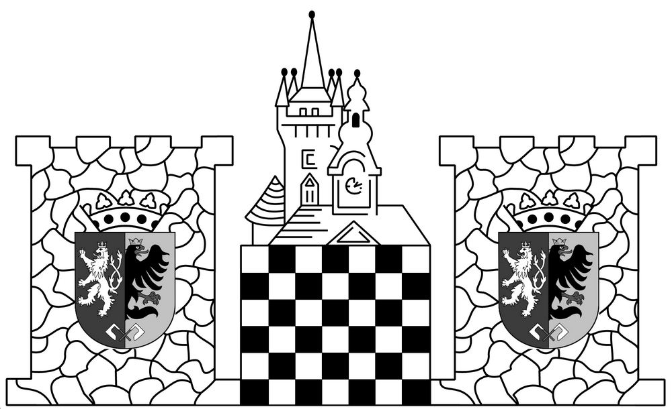
http://stefanydes.cz

FIDE OPEN POLIČKA 2015
4th – 11th July 2015
The Festival is under the auspices of the Policka mayor Mr. Jaroslav Martinu.

Organizer: TJ Štefanydes Polička
Place: Sokol Hall in Polička, Tyršova 60, Polička 572 01
Datum konání: 4th – 11th July 2015
Festival director: Bc. David Schaffer, Hrubínova 560, 572 01 Polička
DSchaffer@seznam.cz, tel.: 731 012 518
Main referee: Bc. David Schaffer

Applications: Obligatory registrations together with accommodation orders should be sent by June 14th 2015 to the adress of the organiser..

Starting fee: GM, IM conditions upon agreement
FIDE ELO 2301+ 300 CZK
FIDE ELO 2200-2300 400 CZK
FIDE ELO 2001-2200 500 CZK
FIDE ELO 1901-2000 600 CZK
FIDE či ČR ELO 0-1900 700 CZK
Each player who is going to take part in this tournament is obliged to have a FIDE ID. If you have not a FIDE ID yet (all players who have ELO FIDE have also FIDE ID), you have to ask for it your national FIDE rating officer. Players without assigned FIDE ID can't participate in the tournament!
Discounts from payments: Young players up to 15 years of age (2000 and younger), pensioners (1955 and older) and handicapped players have discount 100 CZK.

Accommodation:
Hotel Opus (300 m from playing hall)
(single or double rooms with a toilet and a shower, fridge, wi-fi, 290 CZK/night).
SOU obchodní Polička school hostel (1 500 m from playing hall)
Triple rooms with a toilet and a shower on the floor, wi-fi, kitche on the floor, 200 CZK/night)
Accommodation in Sokol Hall
(for modest, mats available, a toilet and a shower on the floor, 50 CZK/night)

Time schedule:
Fri July 3rd 4-7 p.m. possibility of players’ arrival Sat July 4th 10 a.m.- 1 p.m. registration FIDE OPEN
16:30 p.m. 1st round
Sun July 5th 09:30 a.m. 2nd round
Sun July 5th 16:30 p.m. 3rd round
Mon July 6th 9:00-9:45 a.m registration Bughouse
10:00 a.m.- 14:30 p.m. Bughouse tournament
16:30 p.m. 4th round
Tue July 7th 16:30 p.m. 5th round
Wed July 8th 16:30 p.m. 6th round
Thu 9th 16:30 p.m. 7th round
Fri 10th 16:30 p.m. 8th round
Sat 11th 9:00 a.m. 9th round

System of play: Swiss open tournament, 9 rounds, 2 x 90 minutes + 30s per move, waiting time is 1 h in case of late arrival
Criteria used for ranking:
number of points, middle Buchholz, Buchholz, number of wins, Sonnenborn-Berger, average ELO of rivals
Financial prizes: Tournament prize fund: altogether 33.000 CZK
10 000 CZK / 7 000 CZK / 5 000 CZK / 3 000 CZK / 2 000 CZK / 1 500 CZK / 1 000 CZK
the best woman: 500 CZK
the best young player (2000 and younger): 500 CZK
the best senior (1955 and older): 500 CZK
the best player between 1751 - 1950 ELO: 500 CZK
the best player between 1551 - 1750 ELO: 500 CZK
the best player between 1251 - 1550 ELO: 500 CZK

The prize for the best player between… is not possible to combine with main financial prizes. This categories with categories of women, young players and seniors will be paid in the case of 3 players in a given category. Ths tournament prize fund is valid in participation of 60 players. In another case will be modified.
Starting list: regual updates on http://chess-results.com/.

Accompanying programme:
Blitz tournament, bowling etc.

Additional info: The bulletins of tournament with 8 games will be available every day.The tournament results will be sent to the Czech Chess Federation for calculation of FIDE and czech national ELO. Further information can be received from the organiser.

Information about Polička:
Polička serves as a gateway to the Žďár Hills (Žďárské vrchy), one of the most beautiful parts of the Czech-Moravian Highlands (Českomoravská vrchovina). Polička used to be a dowry town of Czech Queens in the past, and was one of the richest cities in Eastern Bohemia during 18th century. The historic town centre is encircled by an impressive wall, some 1220 metres long, fortified with 19 towers, and has a gallery partly open for public. A fine Marian Pillar, amongst the most remarkable monuments of its sort in the Czech Republic, is located in the main square, near to the baroque City Hall with its Municipal Art Museum.The dominant feature of the city is St. James' Church. Internationally famous composer Bohuslav Martinů was born and grew up in a little room in its tower. (His birth place is open to public.) The Bohuslav Martinů Centre in Polička houses a new exhibition about the life and work of the composer, as well as displays detailing the history of the area and exhibitions of the fine local glasswork.
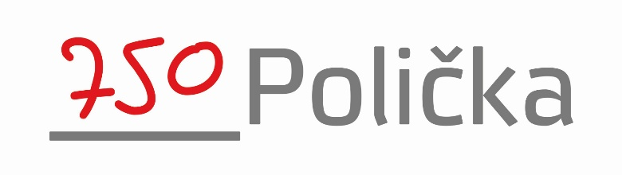

You are cordially invited to our tournament!

